MEMBER REPORT

ESCAP/WMO Typhoon Committee
41st Session

19 – 24 January 2009
Chiang Mai, Thailand

(Macao, China)
CONTENTS

Page
- Overview of tropical cyclones which have affected/impacted 3-9
Member’s area since the last Typhoon Committee Session

- Summary of progress in Key Result Areas 9-18

1. Progress on Key Result Area 1
- Progress on Key Result Area 2
- Progress on Key Result Area 3
- Progress on Key Result Area 4
- Progress on Key Result Area 5
- Progress on Key Result Area 6
- Progress on Key Result Area 7

- Resource Mobilization Activities 18

- Update of Members’ Working Groups representatives 18-19

  - Overview of tropical cyclones which have affected/impacted Member’s area in 2008

- Meteorological Assessment (highlighting forecasting issues/impacts)

Six tropical cyclones affected Macao in the calendar year of 2008, including Neoguri (0801), Fengshen (0806), Kammuri (0809), Nuri (0812), Hagupit (0814) and Higos (0817) successively. This annual number of tropical cyclones was close to the annual average of 5.65, and it was the second year with 4 tropical cyclones: Neoguri, Kammuri, Nuri and Hagupit, that necessitated the hoisting of Gale Signals No. 8 since 1993.

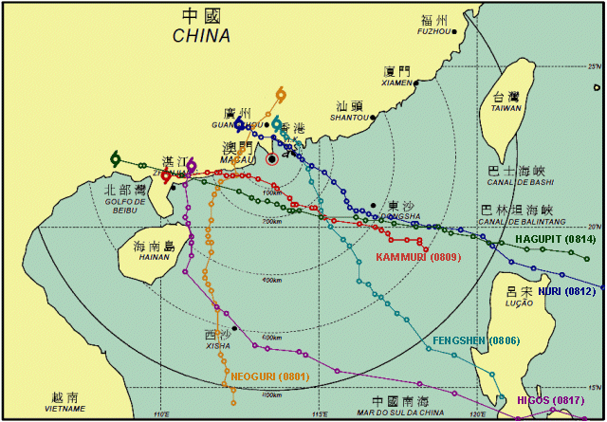

Typhoon “Neoguri”(0801)

A tropical depression developed into a tropical storm in South China Sea and was named Neoguri (0801) in the morning on 15 April 2008. As it was moving north-northwestwards, it intensified into a severe tropical storm in the morning and then a typhoon in the evening on 16 April. After passing the eastern Hainan, Neoguri weakened into a severe tropical storm and then a tropical storm on 18 and 19 April respectively, and made landfall to the east of Yangjiang in Guangdong Province on 19 April. Neoguri was closest to Macao about 100 km to the west-northwest at 19:00 L.T. on 19 April.
Neoguri was the earliest typhoon which had ever affected Macao, even before the annual “Tai Fong” Exercise scheduled and coordinated by Macao Security Forces Coordination Office. Although Neoguri was weakening during its approach to the Guangdong coastal areas, Macao was affected by its gale winds and associated rain-bands and the Gale Signal No. 8 SE was hoisted.

Date | Time* | Signal Hoisted
17/APR | 16:15 | No.1
18//APR | 20:45 | No.3
19/APR | 13:30 | Gale Signal No. 8SE
19/APR | 19:30 | No.3
19/APR | 04:00 | All signals lowered

Typhoon “Fengshen”(0806)

Fengshen intensified from a tropical depression into a tropical storm and was named on 18 June, to the southeast of the Philippines. Generally, it was moving northwestwards over South China Sea. It further developed into a typhoon to the east of the Philippines on 21 June. Fengshen was about 90 km east of Macau when it was closest at 04:00 L.T. on 25 June. It landed at Shenzhen on 25 June and dissipated on 26 June.
With the northerly air-streams constrained by the topography friction, no gale winds were recorded by AWS even it was very close to Macao. Hence, the highest signal hoisted during its passage was No. 3 only.

Date | Time* | Signal Hoisted
23/JUN | 09:30 | No.1
24/JUN | 22:30 | No.3
25/JUN | 18:30 | All signals lowered

S.T.S. “Kammuri”(0809)

On 5 August, a tropical depression intensified into a tropical storm and was named Kammuri. It was moving west-northwestwards over South China Sea. It further intensified into a severe tropical storm on 6 August about 160 km south-southeast of Macao. Kammuri was closest at about 80 km to the south-southwest of Macao at 14:00 L.T. on 6 August It made landfall near Yangjiang in Guangdong Province that evening and dissipated overland.
Slight local flooding occurred in low-lying areas of Macao and it was forecast by the storm surge model.

Date | Time* | Signal Hoisted
4/AUG | 13:00 | No.1
5/AUG | 20:15 | No.3
6/AUG | 07:00 | Gale Signal No. 8NE
6/AUG | 14:00 | Gale Signal No. 8SE
6/AUG | 20:00 | No.3
7/AUG | 04:15 | All signals lowered

Typhoon “Nuri”(0812)

On 18 August, a tropical depresson intensified into a tropical storm over Northwest Pacific and was named Nuri. It was moving west-northwestwards towards the Pearl River Delta. It further enhanced into a typhoon in the morning on 19 August over the Pacific. Nuri was closest to Macao about 60 km to the northeast at 22:00 L.T. on 22 August, and it made landfall in Hong Kong and dissipated gradually.
It was forecast that Nuri would pass Macao to the north after making landfall, and the southwesterly gale winds would replace the northwesterly. Gale Signal No.8NW was hoisted around noon and No.8SW in the evening on 22 August. Gale winds were recorded till the next morning.

Date | Time* | Signal Hoisted
20/AUG | 20:00 | No.1
22/AUG | 00:30 | No.3
22/AUG | 12:30 | Gale Signal No. 8NW
22/AUG | 20:00 | Gale Signal No. 8SW
23/AUG | 00:30 | No.3
23/AUG | 11:00 | All signals lowered

Typhoon “Hagupit”(0814)

A depression developed into a tropical storm and was named Hagupit on 19 September. It further strengthened into a typhoon to the northeast of Luzon on 21 September. Hagupit was fast moving west-northwestwards over South China Sea. It was closest at about 140 kilometers south of Macao at 23:00 L.T. on 23 September and landed in the vicinity of Dianbai County of the western Guangdong Province.
The local flooding induced by Hagupit was the most serious one since 1993 and water depth of 1.5 m above ground level was reported. On the other hand, the wind speed recorded in Macao arose from 40 km/h to 70 km/h within 2 hours in the afternoon on 23 September.

Date | Time* | Signal Hoisted
22/SEP | 22:00 | No.1
23/SEP | 13:00 | No.3
23/SEP | 19:15 | Gale Signal No. 8NE
24/SEP | 03:00 | Gale Signal No. 8SE
24/SEP | 09:30 | No.3
24/SEP | 16:00 | All signals lowered

T. S. “Higos”(0817)

On 30 September, a tropical depression intensified into a tropical storm to the southeast of the Philippines over the Northwest Pacific and was named Higos. It was moving west-northwestwards until 3 October and then veered to the north on 4 October. Higos made landfall near Wuchuan in Guangdong Province and was closest to Macao about 260 km to the west-southwest at 02:00 L.T. on 5 October.
Higos was rather unstable in both its track and its strength. Gale winds were recorded in a short period in the following day after Higos making landfall and Macao was influenced by its residual circulation.

Date | Time* | Signal Hoisted
02/OCT | 21:45 | No.1
05/OCT | 03:00 | All signals lowered

*All time mentioned above is local time

- Hydrological Assessment (highlighting water-related issues/impact)

Tropical Cyclone | Rainfall During The Signal Hoisting Period (mm) | Local Flooding  (m)
Neoguri (0801) | 98.2 - 121.6 | ---
Fengshen (0806) | 125.6 - 179.8 | ---
Kammuri (0809) | 87.2 - 100.0 | <0.5
Nuri (0812) | 82.2 - 91.6 | ---
Hagupit (0814) | 80.8 - 104.8 | Approx 1.5
Higos (0817) | 49.8 - 89.0 | ---

During the passage of Kammuri, slight local flooding occurred with water depth within 0.5 m above ground level reported.

The storm surge induced by Hagupit resulted in the most serious local flooding in Macao since 1993. Water depth of 1.5 m above ground level was reported in low-lying coastal areas that affected greatly the living of citizens, as well as tourists. Although flooding was predicted by the storm surge model and announced, the public lacked awareness or preparedness of its impact and thus great financial losses were inflicted.

- Socio-Economic Assessment (highlighting socio-economic and DPP issues/impacts)

(a) As of November 2008, not few typhoons affected Macao and led to numbers of damages in the year. Table A shown below is some damage figures caused by tropical cyclones this year. It shows obviously in the table that damages caused by Typhoon “Hagupit” are the most in terms of number and effect. “Hagupit” brought strong winds and heavy rainfall, and associated with the high tide, as a result, a lot of seawater poured into Macao and made most of low-lying coastal areas flooding. Many citizens and businesses were affected or inflicted huge financial losses.

On the other hand, there is a concern that Typhoon “Negouri” was the first tropical cyclone hit Macao this year, and was also the earliest typhoon affected Macao since last four decades. This seems to be a sign that typhoon and its relative natural disasters are changing variously in terms of the intensity, pattern as well as impacts. Therefore, some relevant government departments in Macao are having insight into these aspects, and some further actions will be taken if necessary.

Date & Time |  | Name of Tropical Cyclone | Highest  Signal Hoisted | Damages
 |  | Name of Tropical Cyclone | Highest  Signal Hoisted | Flooding | Tree | Billboard | Scaffolding | Window /Awning | Others
Start | End
18-Apr-08  16H15 | 20-Apr-08  04H00 | Neoguri  (0801) | 8 | --- | 12 | 8 | 8 | 3 | 21
23-Jun-08  09H30 | 25-Jun-08  18H30 | Fengshen  （0806） | 3 | --- | 3 | 6 | 4 | 1 | 2
04-Aug-08  13H00 | 07-Aug-08  04H15 | Kammuri  (0809) | 8 | 2 | 19 | 45 | 9 | 4 | 16
20-Aug-08  20H00 | 23-Aug-08  11H00 | Nuri  (0812) | 8 | --- | 5 | 34 | --- | 4 | 19
23-Sep-08  19H15 | 24-Sep-08  09H30 | Hagupit  (0814) | 8 | 15 | 26 | 53 | 13 | 16 | 87
02-Oct-08  21H45 | 05-Oct-08  03H00 | Higos  (0817) | 1 | --- | 2 | 1 | --- | --- | ---
Table A. Figures of damages caused by tropical cyclones in Macao within the year.

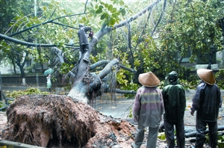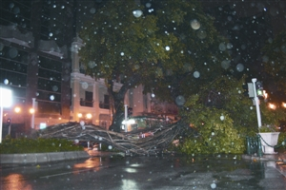
Trees blown down by strong winds during the passage of typhoon.

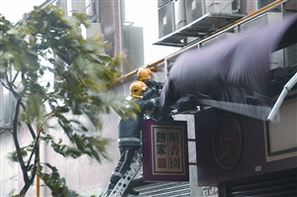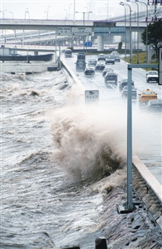

(b) The total number of damages resulted from torrential rain in Macao increased obviously this year than that in last year. According to the number of the issuances of rainstorm warning and their damages shown in the following Table B, the figures reveals that flooding and the landslip were the major impacts of heavy rainfall.
Firemen were clearing a toppling billboard.

Date | Duration | Damages
Date | Duration | Flooding | Tree | Billboard | Outer wall of building | Scaffolding | Awning | Landslip | Casualties
06-Jun-08 | 11H00-12H45 | 20 | 1 | --- | --- | --- | --- | 3 | ---
07-Jun-08 | 18H00-20H50 | 5 | 2 | 1 | --- | --- | --- | 2 | ---
25-Jun-08 | 07H10-11H10 | --- | 1 | 2 | --- | 2 | 1 | --- | ---
28-Jun-08 | 16H28-17H30 | --- | --- | --- | --- | --- | --- | 1 | ---
10-Jul-08 | 05H25-11H00 | --- | 1 | --- | --- | --- | --- | 1 | ---
11~12-Jul-08 | 22H20-02H23 | 1 | 1 | --- | --- | --- | --- | --- | ---
05-Oct-08 | 02H20-08H00 | --- | --- | --- | --- | --- | --- | --- | ---
Table B. Rainstorm warnings issued in Macao within the year and their respective damages.
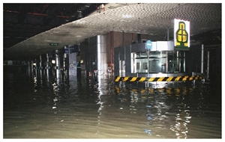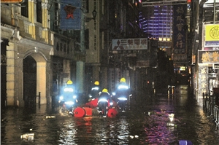
Floods and landslips caused by the combination of torrential rain and high tide during the passage of typhoon “Hagupit”.

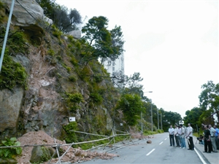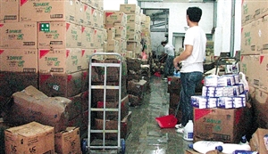

A scene in Macao during the passage of typhoon.
- Regional Cooperation Assessment (highlighting regional cooperation successes and challenges)
Nil.

  - Summary of progress in Key Result Areas (For achievements/results which apply to more than one Key Result Area, please describe them under the most applicable Key Result Area. Then, at the end of the description, place in parentheses ( ) the other applicable Key Result Areas)

- Progress on Key Result Area 1: Reduced Loss of Life from Typhoon-related Disasters. (List progress on the Strategic Goals and Associated Activities in the Strategic Plan and progress on the 2008 Typhoon Committee Annual Operating Plan goals)

  - Meteorological Achievements/Results

The MTSAT ground receiving system was installed in March 2008 and the FengyunCast broadcast ground receiving system in April 2008. Both enhance the ability of the forecasters to perform better analysis of the position and intensity of the tropical cyclones from satellite imagery by the method of Dvorak.

The Typhoon Integrated System (TIS) II of Macao Meteorological and Geophysical Bureau (SMG), was replacing the TIS I in 2008. This new version aims to divide the work into modules so as to maximize job efficiency and system scalability, enhance the reusability of the data being fed into the system and emphasize automation. The three major working components of the system are,

- tropical cyclone warning is being decoded and injected into the database automatically;
- typhoon-warning chart should be generated with human intervention at a minimal level;
- hardcopy output part of the system (i.e. tropical cyclone reports).

The former two parts run under the Linux platform (fig.1 – fig. 4) on a regular automated basis, while the reporting function works under the MS Windows environment (fig.4 – fig.5) to enjoy the user-friendliness offered.

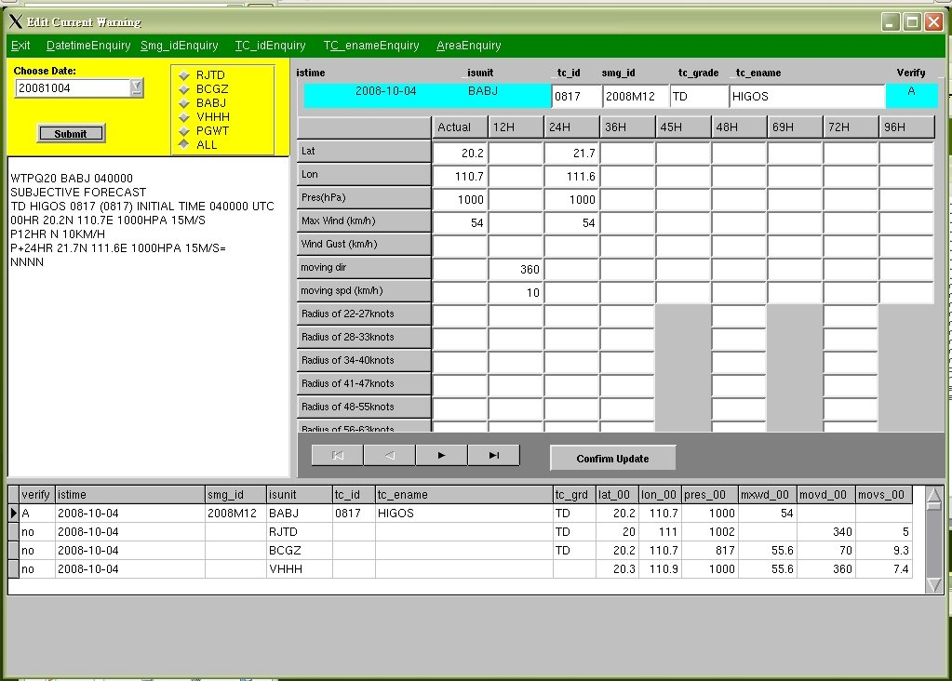
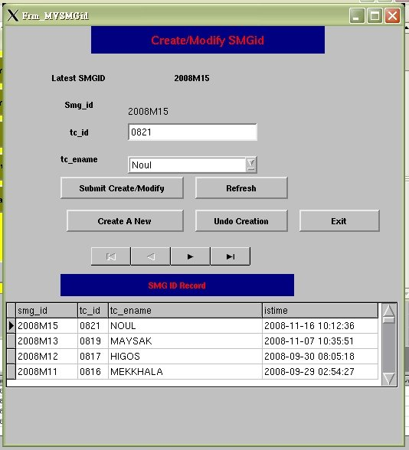

Fig.1 Fig.2
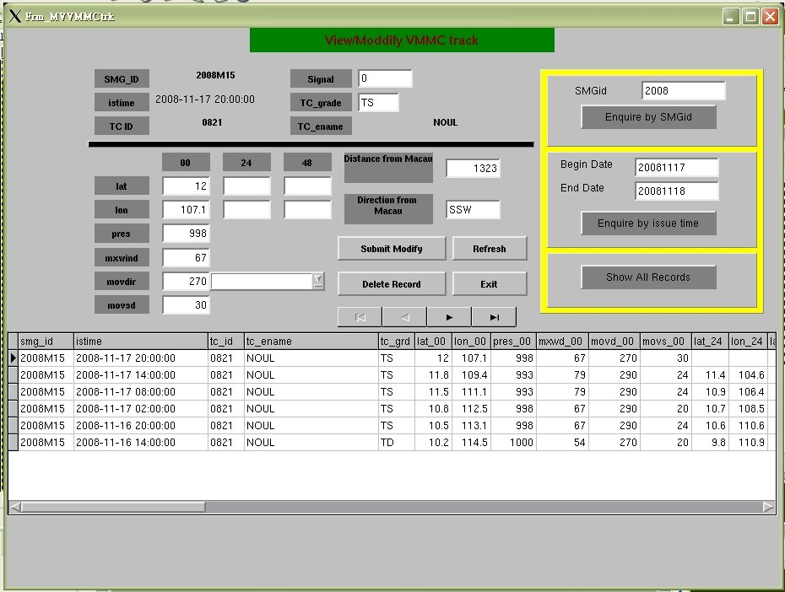
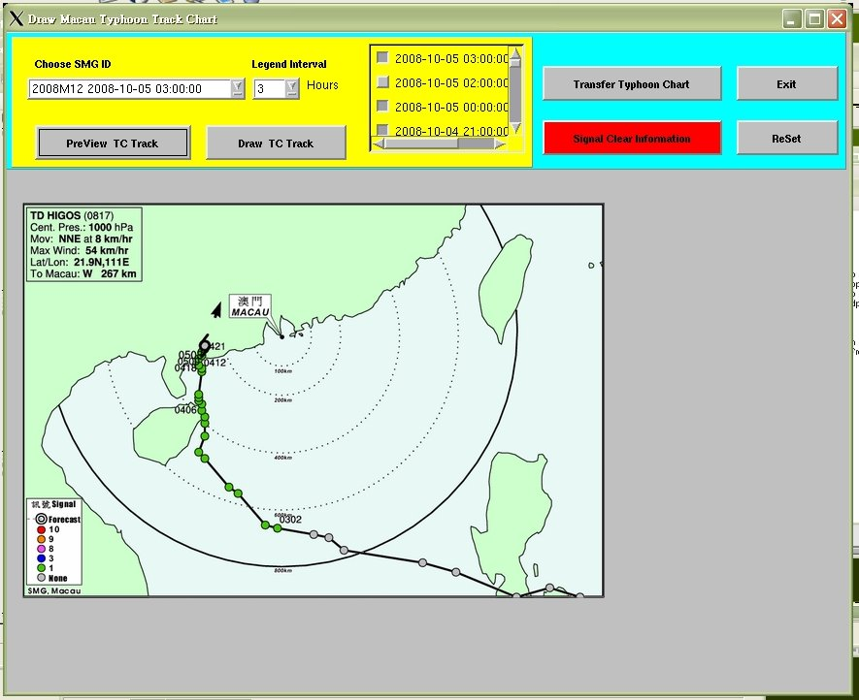

Fig.3 Fig.4
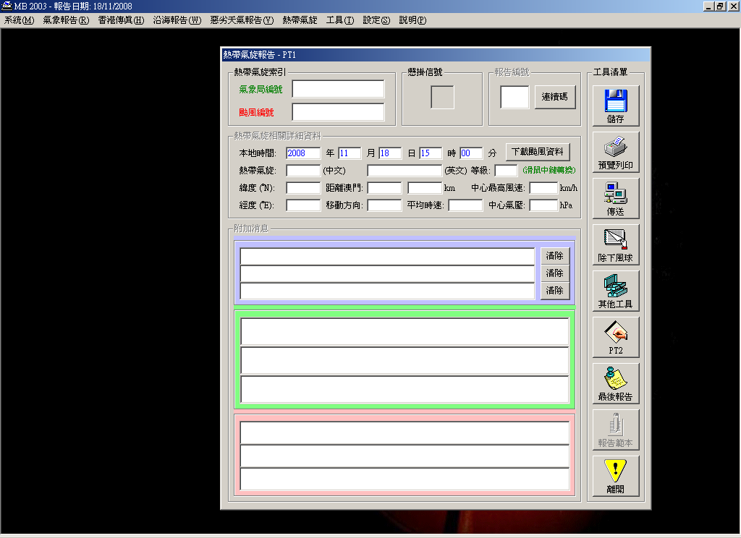
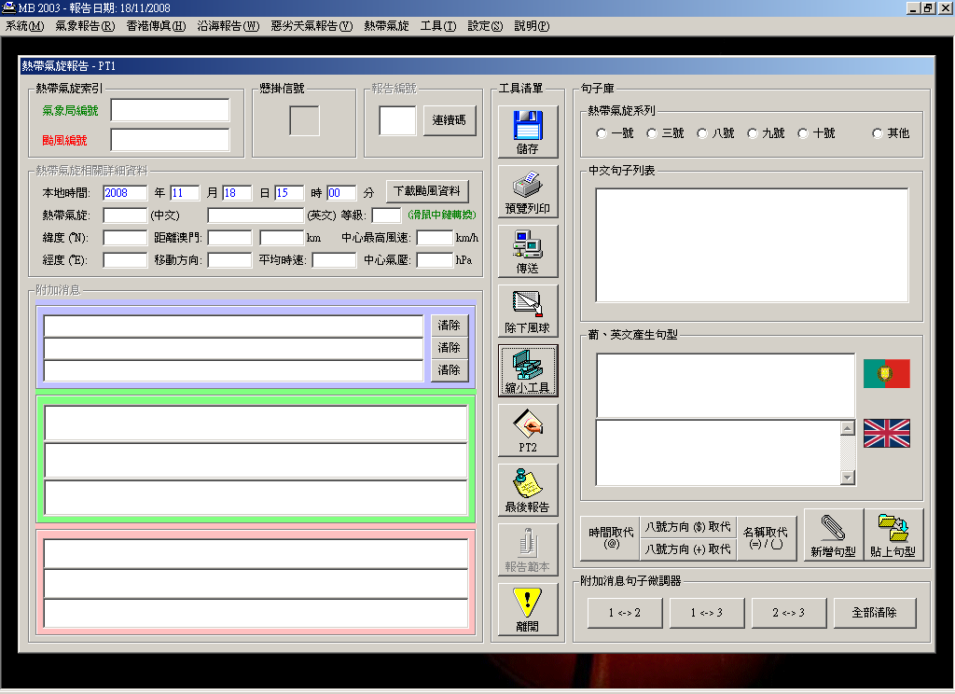

Fig.5 Fig.6

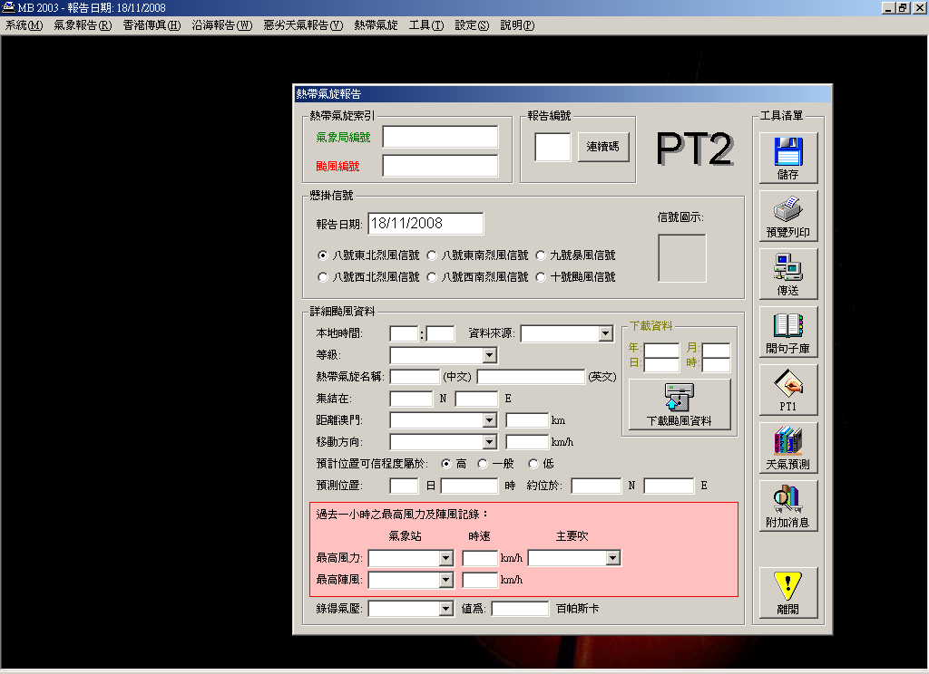
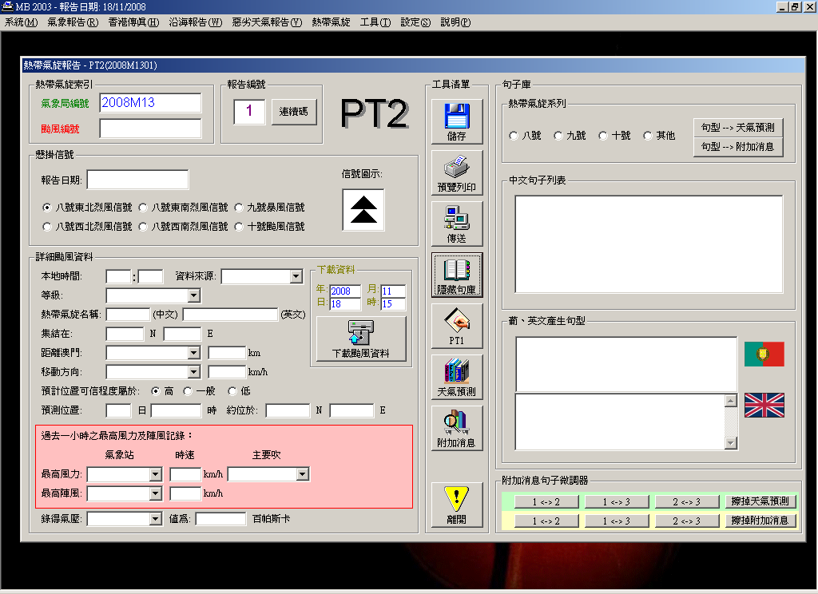

fig.7

Fig.7 Fig.8

The purchase of a new dual polarization X-band Doppler radar has started in 2008 and is expected to put into operation before June 2009.

  - Hydrological Achievements/Results
Cooperation among different government organizations for the establishment of an automatic flooding monitoring system has started right after the serious local flooding induced by Typhoon Hagupit, consisting nine land- and 2 seashore-stations and one tide and wave recorder to monitor the actual flooding conditions in the low-lying areas, with the data centralized at SMG for further dissemination.

  - Disaster Prevention and Preparedness Achievements/Results

Despite typhoon and its related disasters neither affected to Macao greatly nor caused serious casualties in the past, Macao government has never shown any neglect of their impacts but has paid continuing efforts on the enhancement of various effective measures in order to reduce any possibility of resulting in casualties. Some efforts and contributions made by Macao government in 2008 are shown as follows:

Since some signs showed that typhoon-related disasters in terms of intensity and impacts were changing, and also considering of Macao’s rapid development in recent years and a vast numbers of large construction project under construction, it was foreseen that risk on collapse of building and casualties caused by typhoon or other relative disasters would be increasing as well. For these reasons, Security Forces Coordination Office in cooperation with another government department, Land, Public Works and Transport Bureau, has launched a program entitled “Task Force on Mobilization of Heavy Machinery in Excavation and Rescue Works” since 2006, so as to enhance the capacity of Civil Protection Framework for emergency response and to reduce number of casualties by carrying out timely rescue operation. The program was made considerable progress after extensive discussions between two parties through holding of meetings, and consulting to some other relevant departments. The final draft of the plan is expected to be submitted to relevant leaderships for approval in near future and to be firmly implemented afterward.

One of the major impacts of typhoon in Macao was resulting in of landslip. To avoid the occurrence of landslide and resulting in loss of life, Macao government invested not little money in reinforcement of slope works and inspection of any risky slopes, and the improvement works as well as corresponding measures were also made every year.

  - Research, Training, and Other Achievements/Results

Two forecasters received one-week on-job training at the Central Forecasting Office of Hong Kong Observatory in May 2008, covering the area of tropical cyclone forecasts and warnings.

Twenty meteorological staffs completed a five-day advanced course on the application of Doppler radars, with topics on tropical cyclones, in November 2008, organized locally and lectured by Dr. Yu Xiaoding from Training Centre of China Meteorological Administration.

  - Regional Cooperation Achievements/Results

Nil.

  - Identified Opportunities/Challenges for Future Achievements/Results

SMG will be responsible of planning and issuing the flooding warnings to the public, being at least 12 hours ahead if induced by storm surge, starting from March 2009.

- Progress on Key Result Area 2: Minimized Typhoon-related Social and Economic Impacts. (List progress on the Strategic Goals and Associated Activities in the Strategic Plan and progress on the 2008 Typhoon Committee Annual Operating Plan goals)

  - Meteorological Achievements/Results

Please refer to Key Result Area 1(a).

Intense communication among SMG and different organizations within Civil Protection Framework has been carried out once the tropical cyclone signal No. 1 is hoisted to promote better awareness and preparedness.

  - Hydrological Achievements/Results

Please refer to Key Result Area 1(b).

  - Disaster Prevention and Preparedness Achievements/Results

Flood took place in some low-lying areas in Macao was another major impact of typhoon, and certain inconvenience and economic losses to the public and some business owners were caused during the flooding. In this regard, Macao’s relevant departments continued to carry out some sanitation reconstructions to improve the drainage network and minimize the occurrence of flooding.

During the passage of Typhoon “Hagupit” in this year, the typhoon brought strong winds and a lot of rainfall and also associated with the high tide, consequently, they made plenty of seawater surged into Macao and caused some low-lying coastal areas flooding, which made many businesses in these areas suffered from the severe financial losses as a result. For this reason, Macao government not only adopted an immediate relief and made some urgent repairs on infrastructures but also provided the affected business owners and fishermen with assistance of interest-free loan. On the other hand, strengthening of the measure of financial assistance as well as other contingency mechanisms were also reviewed and discussed by the public and private sectors through holding of certain meetings.

  - Research, Training, and Other Achievements/Results

Around 800 students and citizens visited SMG in 2008 to have better understanding of our operation and the meaning of different warnings hoisted or issued.

  - Regional Cooperation Achievements/Results
Nil.

  - Identified Opportunities/Challenges for Future Achievements/Results

Please refer to Key Result Area 1(e).

General tropical cyclone information will be provided to civil servants on the website of Public Administration and Civil Service Bureau, while advanced and restricted information to decision makers of organizations within Civil Protection Framework, during tropical cyclones approaching, with password protected, in 2009.

- Progress on Key Result Area 3: Enhanced Beneficial Typhoon-related Effects for the Betterment of Quality of life. (List progress on the Strategic Goals and Associated Activities in the Strategic Plan and progress on the 2008 Typhoon Committee Annual Operating Plan goals)

  - Meteorological Achievements/Results

Nil.

  - Hydrological Achievements/Results

Nil.

  - Disaster Prevention and Preparedness Achievements/Results

Apart from the reinforcement of slope works, the improvement of drainage network, providing with the building maintenance support, and acceleration of the affected business owners’ application for financial aid, stated on 1(c), 2(c) and 5(c), the closer cooperation among government departments and societies and, the establishment of such disaster risk management as Flooding Warnings have been undertaking since the government and the public’s awareness of the impacts made by the recent typhoon-related disasters has been raising, and this has led to an increase in the demand for further enhancing disaster warning and prevention.

  - Research, Training, and Other Achievements/Results

Nil.

  - Regional Cooperation Achievements/Results

Nil.

  - Identified Opportunities/Challenges for Future Achievements/Results

Nil.

- Progress on Key Result Area 4: Improved Typhoon-related Disaster Risk Management in Various Sectors. (List progress on the Strategic Goals and Associated Activities in the Strategic Plan and progress on the 2008 Typhoon Committee Annual Operating Plan goals)

  - Meteorological Achievements/Results
The SMG Emergency Plan was revised and rehearsed in 2008 to ensure the provision of meteorological services, including tropical cyclone forecasts and warnings, in all-weather.

  - Hydrological Achievements/Results

Nil.

  - Disaster Prevention and Preparedness Achievements/Results

In order to enhance members’ capabilities of coping with various typhoon-related disasters within Macao’s Civil Protection Framework and to improve the communication and coordination between members, a major emergency contingency plan in relation with the typhoon-related fields must be reviewed and updated at least once a year. And the revision with all new updated information will be distributed to each member and other relevant departments for them to take any corresponding action or cooperation accordingly.

A large-scale exercise to simulate the occurrence of typhoon and its various impacts, carried out by more than twenty departments and agencies in either public or private sector and with participants more than 800, is organized by Macao Security Forces Coordination Office annually before the coming of typhoon season every year. The exercise is not only helpful for participants from all members within Civil Protection Framework to practice operation procedures in relation with civil protection and emergency plans, but also provides a valuable opportunity in testing the effectiveness of civil protection system and seeking any of weaknesses for improvement.

It is undoubted that maintaining of good communication and close cooperation amongst departments will be helpful to disaster prevention and preparedness, since assessment of the impacts of typhoon-related disaster from different points of view and aspects and formulating of countermeasures will be able to be facilitated through the active and effective exchange of information and opinions between them. Therefore, Macao Security Forces Coordination Office organizes or coordinates different meetings irregularly with government departments or other agencies in private sector every year, in which, a meeting mainly for civil protection with representatives from all members of Civil Protection Framework is held annually. The aims of the meeting are to review the problems found in the exercise mentioned above, discuss all available and relative measures and mechanisms, and also collect different opinions for any possible improvement.

  - Research, Training, and Other Achievements/Results

Nil.
  - Regional Cooperation Achievements/Results

Nil.

  - Identified Opportunities/Challenges for Future Achievements/Results

Nil.

- Progress on Key Result Area 5: Strengthened Resilience of Communities to Typhoon-related Disasters. (List progress on the Strategic Goals and Associated Activities in the Strategic Plan and progress on the 2008 Typhoon Committee Annual Operating Plan goals)

  - Meteorological Achievements/Results

Nil.

  - Hydrological Achievements/Results

Nil.

  - Disaster Prevention and Preparedness Achievements/Results

Despite neither serious nor major disaster occurred in MSAR, Macao government always makes efforts to improving the citizen’s security and quality of living. In this regard, certain large infrastructure programs, community reconstruction works and other improvement projects related to the safety of slope, coast protection and sanitation network for better flood mitigation, and so on, continued to be executed by some relevant government departments in the year.

On the other hand, Macao government also pays attention to citizen’s life and property security. Therefore, a program entitled Interest-free Loan Scheme for Building Maintenance provided by one of Macao government department went on available for residents in order to strengthen their capacity of resisting disasters particularly in typhoon, as well as to improve their security and quality of living.

  - Research, Training, and Other Achievements/Results

Nil.

  - Regional Cooperation Achievements/Results

Nil.

  - Identified Opportunities/Challenges for Future Achievements/Results

Nil.

- Progress on Key Result Area 6: Improved Capacity to Generate and Provide Accurate, Timely, and understandable Information on Typhoon-related Threats. (List progress on the Strategic Goals and Associated Activities in the Strategic Plan and progress on the 2008 Typhoon Committee Annual Operating Plan goals)

  - Meteorological Achievements/Results

Please refer to Key Result Area 1(a).

Internal working procedures during tropical cyclones approaching at the Meteorological Watch Centre of SMG was revised and resulted in more frequent and timely information of tropical cyclones and their warnings released to the public through mass media, mainly television and radio.

Tropical cyclone analysis, forecasts and warnings also benefit from the establishment of the new AWS central server to decode and collect date from new weather stations, the implementation of Linux High Availability Cluster as internal file system, and the restructure of internal data storage system to protect data availability and increase performance.

  - Hydrological Achievements/Results

Please refer to Key Result Area 1(b).

  - Disaster Prevention and Preparedness Achievements/Results

Macao has certain pre-defined mechanisms to disseminate the information on typhoon-related threats via such mass media as newspapers, some official or private websites, TV, mobile and so on. During the hoist of typhoon warning signal no.8 in Macao, all information related to victims, status of the city, traffic transports, incidents caused by typhoon, rescue works and so on are distributed from time to time by the officers in the control centre of civil protection and the representative from Macao Government Information Bureau via the mass media and the official website. Furthermore, some guidance on safety and emergency relief, as well as other advices are also well informed to the public, so that people are able to know more about the real-time impacts of typhoon in the city and seek any immediate help or appropriate assistance if necessary, and presence in or approach to any vulnerable places where damages made or incidents taking place is also able to be avoided.

Bulletin boards to inform citizens and tourists of any updates news related severe weather or other relevant information during the passage of typhoon or issuance of rainstorm warning have been extended at all border checkpoints, ferry terminals or in airport.

  - Research, Training, and Other Achievements/Results

Please refer to Key Result Area 1(d).

A public weather server is being set up to provide unique and timely meteorological data, especially tropical cyclone information, downloaded by the mass media themselves.

Relocation of the meteorological office at the Macao-Hong Kong Ferry Terminal for easy access of ship companies and tourists, especially during tropical cyclone signals hoisted.

  - Regional Cooperation Achievements/Results

  - Identified Opportunities/Challenges for Future Achievements/Results

All the mobile phone users can apply for the tropical cyclone warnings through SMS free of charge in 2009, after arrangement made between SMG and the fourth mobile phone company in Macao.

The present SMG website will be enriched with more tropical cyclone information open to the public in both variety and frequency in 2009.

- Progress on Key Result Area 7: Enhanced Typhoon Committee’s Effectiveness and International Collaboration. (List progress on the Strategic Goals and Associated Activities in the Strategic Plan and progress on the 2008 Typhoon Committee Annual Operating Plan goals)

  - Meteorological Achievements/Results

SMG has given support to the research project of Typhoon Committee, mainly collecting the studies on “the trend of the frequency and intensity of tropical cyclones in WNP and SCS”.

  - Hydrological Achievements/Results

Nil.

  - Disaster Prevention and Preparedness Achievements/Results

It is always believed that attending of the meetings held or organized by Typhoon Committee or its working groups is significant for information sharing and experience exchange among Members. Macao Security Forces Coordination Office as a department responsible for civil protection, therefore, delegated representatives to participate actively in following meetings in the last year:
- 21 to 26 November 2007, 40th Session of Typhoon Committee;
- 10 to 11 April 2008, 3rd DDP Meeting;
- 22 to 26 September 2008, Integrated Workshop on Coping with Climate Change in the Typhoon Committee Area.

In addition, Macao Security Forces Coordination Office also worked closely with TC/WGDPP for completion of its priority activities by submitting actively all required reports concerning Macao, such as reports on Early Warning System and Disaster Management System, to enrich the contents of TCDIS. It is hoped that TCDIS will become one of platforms providing Members with much more opportunities to learn more about the principles and actual situations of implementing civil protection system in different levels within Members through the effective communication and exchange of Members and other organizations’ typhoon-related information and issues on the website, and also allowing Members to make use of these available data and other new cognitions to improve or strengthen their own systems and policies for better achievement of minimizing disasters as a result.

  - Research, Training, and Other Achievements/Results

Typhoon Committee’s logo contest in Macao was successfully held and prized by TCS and SMG jointly in 2008, promoting the popularity of TC among Macao population.

  - Regional Cooperation Achievements/Results

Nil.

  - Identified Opportunities/Challenges for Future Achievements/Results

Nil.

  - Resource Mobilization Activities

Nil.

  - Update of Members’ Working Groups representatives

- Working Group on Meteorology

Mr. Tong Tin Ngai
Chief of Meteorological Watch Centre
Macao Meteorological and Geophysical Bureau
Rampa do Observatório, Taipa Grande
Caxia Postal No 93, Macau
Tel: (853) 88986270
Fax: (853) 28850557
E-mail: tntong@smg.gov.mo

- Working Group on Hydrology

Ms. Leong Ka Cheng
Chief of Meteorological Division
Macao Meteorological and Geophysical Bureau
Rampa do Observatório, Taipa Grande
Caxia Postal No 93, Macau
Tel: (853) 88986218
Fax: (853) 28850557
E-mail: kcleong@smg.gov.mo

- Working Group on Disaster Prevention and Preparedness

Mr. Lei Sai Cheong
Superintendent
Macao Security Forces Coordination Office
Calçada dos Quarteis, Edifício da DSFSM
Tel: (853) 87997538 / 87997537
Fax: (853) 28725336
E-mail: copc@fsm.gov.mo

- Training and Research Coordinating Group

Mr. Leong Weng Kun
Chief of Processing and Telecommunication Centre
Macao Meteorological and Geophysical Bureau
Rampa do Observatório, Taipa Grande
Caxia Postal No 93, Macau
Tel: (853) 88986269
Fax: (853) 28850557
E-mail: wkleong@smg.gov.mo

- Resource Mobilization Group

Nil.

